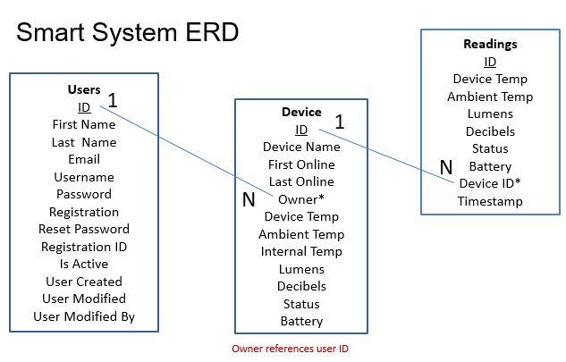

*

**Smart System ERD with the implementation of Web2Py**

The Users table was defined in Web2Py. The Device and Readings table were defined in MySQL then later refined in Web2Py. Refinements included the addition of auto incremented IDs which act as the primary keys in both Device and Readings tables. Device ID was also added to the readings table during the refinements process. This is the foreign key in the Readings table, referencing ID in the devices table.

**Relationships**

Users can have many devices. Each device has one owner.

Device can have many readings. Each reading belongs to one device.